Important Notice

- The Safe is NOT supplied with an over-ride key

- It is therefore important to insert the batteries and set the user code user the instructions supplied, before closing the door

- If the door is accidentally closed before inserting the batteries, connect a 9v battery to the battery port. Whilst holding this in place, touch the screen and enter the pre-set factory code 1,2,3,4 and press the key button ()

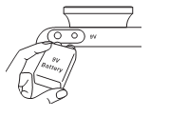
- Now set the user code, using the instructions in the user manual

